# Women’s Safety App: Real-Time Emergency Smart Response through Shake Detection and Automated Alerts

# A COMMUNITY FOCUS PROJECT DOCUMENTACTION

***Submitted by***

**Shaik Sajid (9922008165)**

**Jerish J (9922008116)**

**Abhishek P (9922008187)**

***In partial fulfillment for the award of the degree***

***of***

**BACHELOR OF TECHNOLOGY**

### IN

**INFORMATATION TECHNOLOGY**



**SCHOOL OF COMPUTING   
DEPARTMENT OF INFORMACTION TECHNOLOGY**

**KALASALINGAM ACADEMY OF RESEARCH AND EDUCATION**

# KRISHNANKOIL 626 126

# November - 2025

### Academic Year (2024-2025)

**1. COMMUNITY NEED ASSESSMENTS, ANALYSIS AND OBJECTIVES**

### ****1.1 Community Need Assessment****

Women’s safety continues to be a pressing and universally recognized issue, with alarming statistics underscoring the magnitude of the problem. According to global reports and studies, approximately **one in every three women** experiences some form of **harassment, assault, or violence** in her lifetime—whether in public spaces, workplaces, or even at home. These figures highlight the urgent need for accessible, effective, and responsive safety mechanisms that can provide women with a sense of security in their daily lives.

While numerous mobile applications have emerged over the years aiming to address this issue, many of them fall short in crucial areas such as **ease of use**, **response time**, and **real-time tracking**. Often, these apps require the user to unlock the phone, navigate through several menus, and manually initiate an alert—actions that may not be feasible during an emergency when every second counts.

To better understand the real-world challenges and expectations, we conducted an informal yet insightful **community-based need assessment**, involving direct interaction with **female students, faculty members, and local residents** within our institution and nearby areas. Through one-on-one discussions, feedback sessions, and focus groups, we identified a common pattern: the need for a **safety solution that is intuitive, discreet, and instantly responsive**.

Participants emphasized that in critical situations, they often don’t have the luxury of time or the presence of mind to follow complex app procedures. They expressed a strong preference for an app that could be **triggered effortlessly—such as by a simple gesture like shaking the phone—and that would instantly share their location and alert their trusted contacts**. Additionally, concerns were raised about battery efficiency, offline usability, and reliability during weak network signals, all of which informed our design approach.

This assessment clearly demonstrated a **gap between the existing safety solutions and the practical needs of users**, particularly women navigating public spaces alone. It also reinforced the importance of creating a **smart, accessible, and user-driven application** that not only offers emergency assistance but also instills confidence and peace of mind in its users.

**1.2 Problem Statement:**

Existing mobile applications for women’s safety often require manual access, which becomes impractical during high-stress or emergency scenarios. The community expressed the need for a hands-free, real-time safety application that can:

Instantly alert emergency contacts

Share accurate live location

Work in the background without manual input

**1.3 Objectives:**

To create a reliable Android app focused on women’s safety.

To enable shake detection for hands-free activation.

To integrate GPS, emergency calls, and SMS alerts.

To ensure low battery consumption and real-time performance.

To empower users and create community awareness on personal safety tools.

**2. PROJECT PLANNING AND IMPLEMENTATION**

**2.1 Planning:**

Week 1-2: Community survey and need analysis

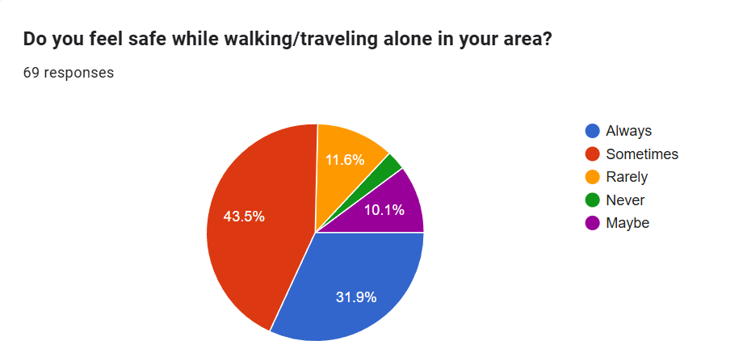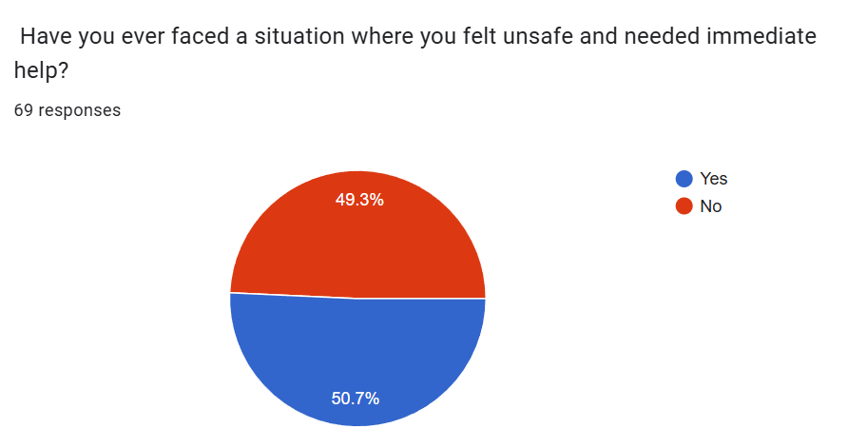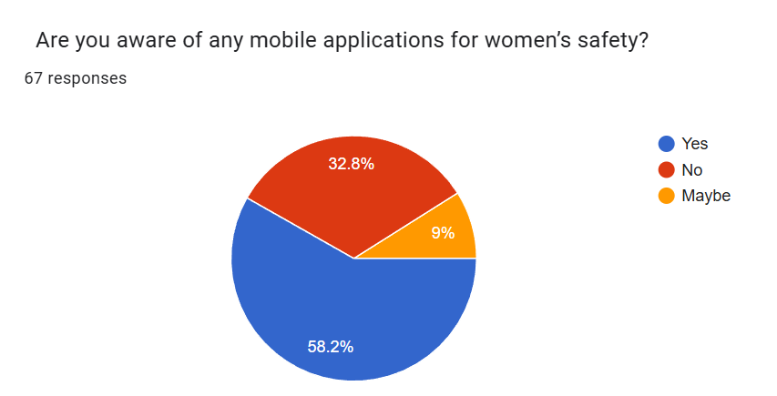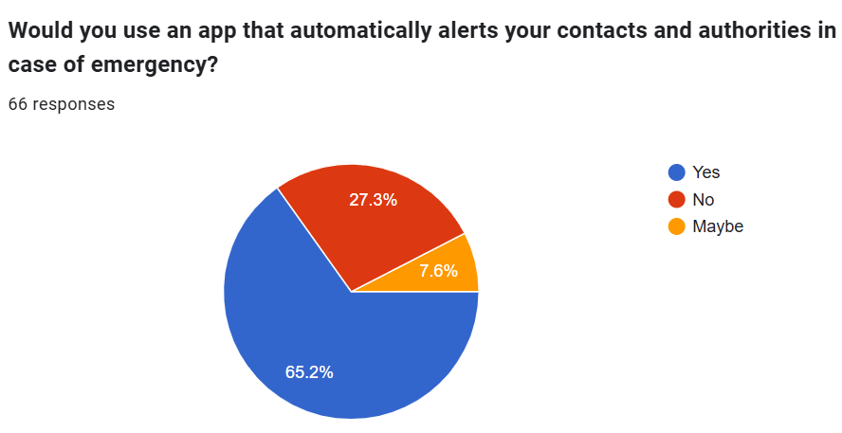

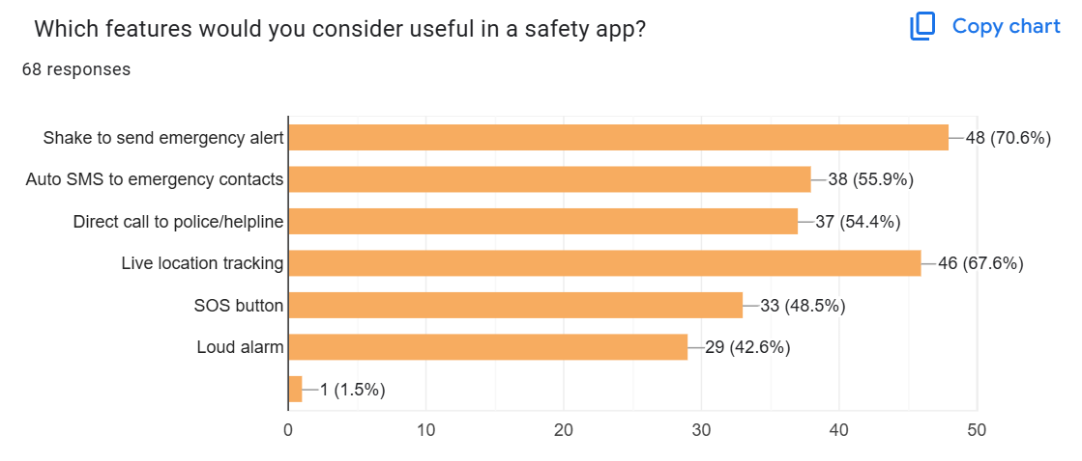

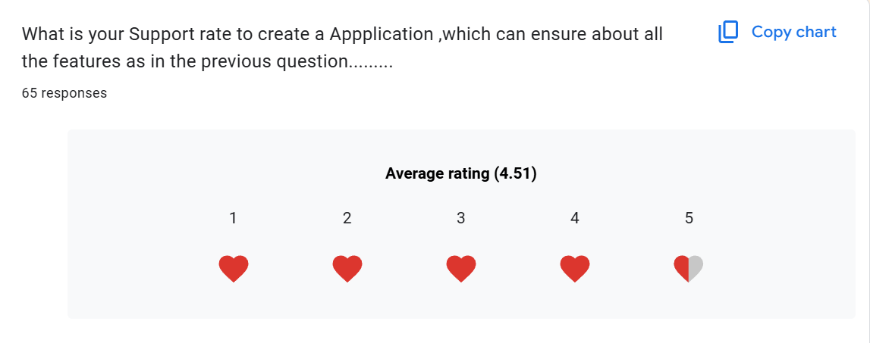

Week 3-4: Literature survey and app concept design

Week 5-6: Development of core modules: Shake detection, SMS, and call APIs

Week 7: UI/UX design, permission flow integration

Week 8: Testing and feedback collection

Week 9: Final deployment and community demonstration

**2.2 Proposed Method**

The proposed architecture of the women’s safety application is designed to deliver a fast, reliable, and automated emergency response system. It is structured into three core layers, each responsible for a critical function in the app’s operation:

Input Layer:

This layer primarily interacts with the device's built-in accelerometer sensor to continuously monitor motion patterns. The app is configured to detect specific shake gestures that indicate distress. These gestures are predefined by a threshold level, and when a user shakes the phone with sufficient force, it signals the system to initiate the next phase of processing.

Processing Layer:

Once a shake gesture is detected, the signal is passed to the processing layer. Here, noise filtering algorithms are employed to eliminate false positives—such as accidental movements or drops. The system validates the intensity, frequency, and duration of the shake against a dynamic threshold to confirm it is a genuine emergency trigger. This ensures accuracy and reduces unnecessary alerts.

Output Layer:

Upon successful validation, the output layer activates a multi-channel emergency response. This includes:

Sending an SMS to registered emergency contacts and the nearest police station, embedding the user’s real-time GPS coordinates.

Automatically placing a call to the primary emergency contact for voice communication.

Activating a loud siren, designed to attract attention from nearby people and potentially deter attackers.

**2.3 User Interface and Features**

The app is designed with simplicity and speed in mind, ensuring that even under stress, users can interact with it efficiently. The core features include:

Start/Stop Monitoring Button:

A user-friendly toggle that allows users to manually start or stop the background monitoring service. This provides flexibility when the user does not require emergency monitoring.

Emergency Number Registration:

Users can input and store key contact numbers such as family members, friends, or local police. These numbers are used by the app to send alerts during emergencies.

Automated Live Location SMS:

Once an emergency is triggered, the app captures the current GPS location of the user and includes it in the alert message sent to all emergency contacts. This helps responders to locate the user quickly and accurately.

Integrated Siren Feature:

A loud, attention-grabbing siren sound is activated to alert nearby individuals. This feature can be life-saving in public spaces, drawing help from bystanders or discouraging threats.

Permissions Screen:

On first use, the app requests essential permissions—location access, SMS sending, and phone call initiation—to ensure smooth operation. A dedicated screen guides users to grant these permissions without confusion, making the setup process seamless and user-friendly.

Figures and Screenshots:

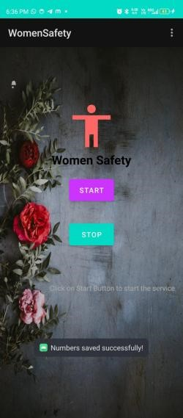

Fig 1: App layout with Start/Stop and number registration

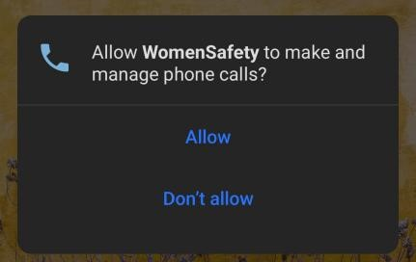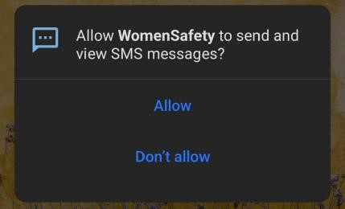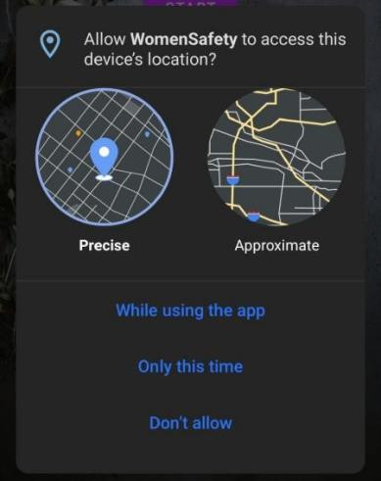

Fig 2,3,4: Permission prompts for phone, SMS, and GPS

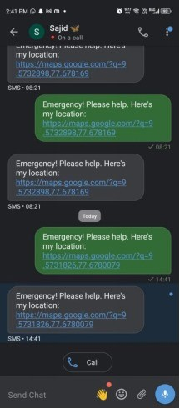

Fig 5: SMS output with Google Maps location



Fig 6: Active emergency call after shake detection

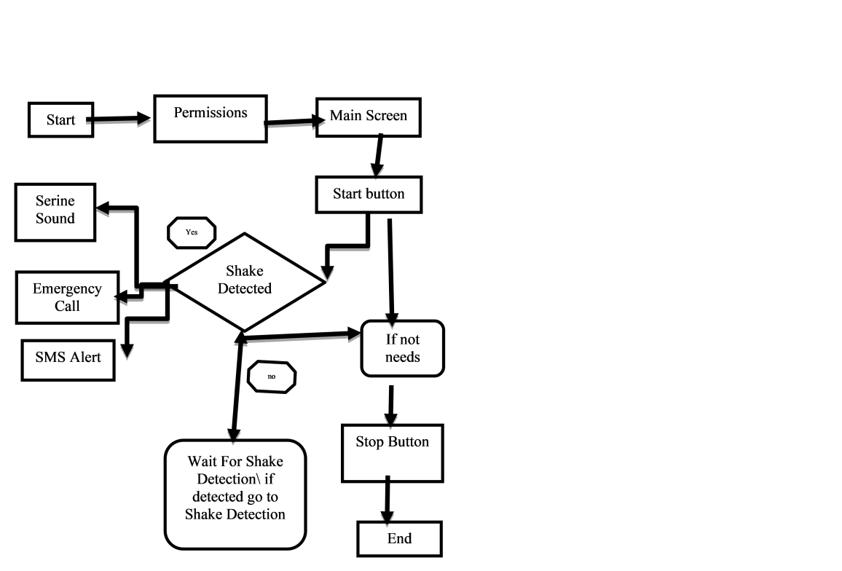

Fig 7: Flowchart explaining emergency protocol activation

1. **COMMUNITY COLLABORATION / PARTNERSHIP**

Our project was developed in collaboration with the Tamil Nadu State Commission for Women, an esteemed body under the Government of Tamil Nadu dedicated to safeguarding and empowering women across the state. This partnership played a critical role in shaping the real-world relevance and usability of our safety application.

* 1. **Nature of Collaboration:**

The Commission facilitated valuable opportunities for interaction with safety educators, women’s rights advocates, and field experts. Through focused group discussions and expert consultations arranged by the Commission, we gathered insights on:

Real-time risk factors women face in urban and semi-urban areas

Practical limitations of existing safety solutions

Emergency response best practices

Their guidance led to key improvements in our app, particularly in:

Designing a user interface that is intuitive for all age groups

Fine-tuning the shake-detection sensitivity based on situational data

Optimizing alert delivery times under different network conditions

* 1. **Community Engagement Activities:**

We conducted live demonstrations of our application for selected members of the community in association with the Commission. These sessions involved:

A walkthrough of app features

Safety drills to simulate emergency situations

Interactive Q&A sessions with feedback collection

Participants included college students, working professionals, and homemakers—each group offering diverse perspectives that helped us customize the alert system more inclusively.

**3.3 Certification and Recognition:**

In recognition of our initiative, we received an official Community Participation Certificate from the Tamil Nadu State Commission for Women. The certificate acknowledges our contribution to enhancing women's safety through innovative technology and highlights our commitment to community-centric solutions.

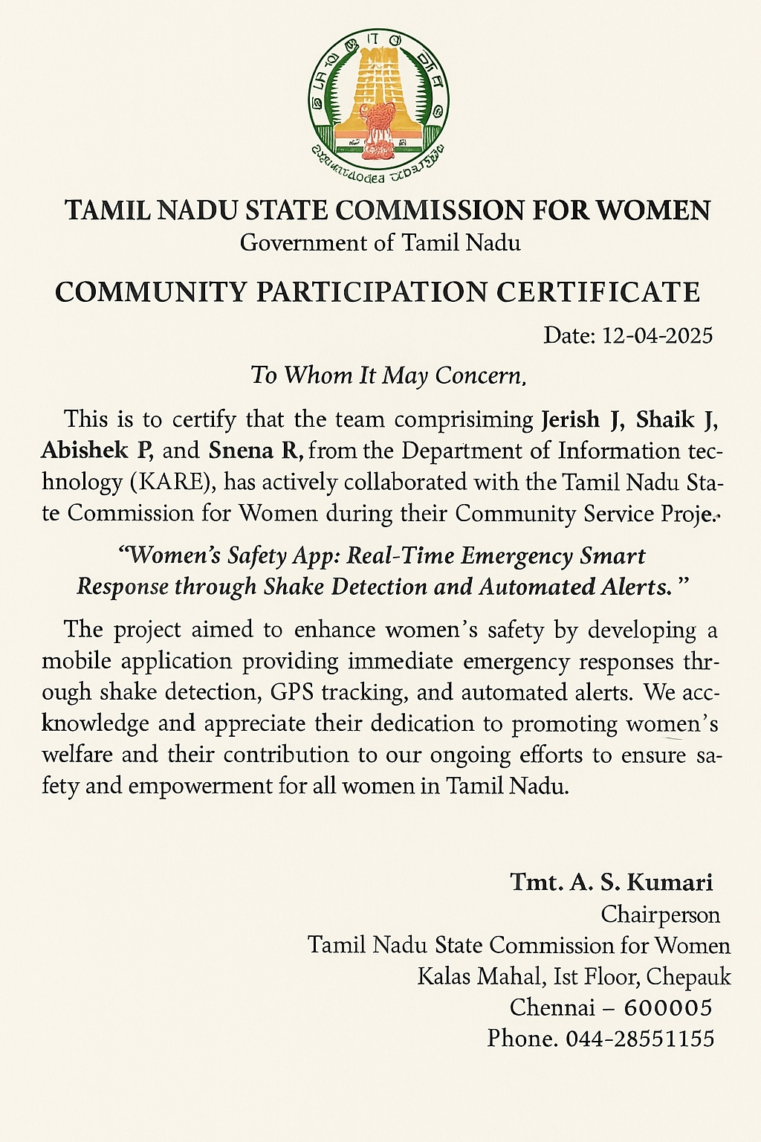

Fig 8: Conformation Latter from community

**3.3 Social Impact:**

Through this collaboration:

Over 50+ women participated in testing and reviewing the application

We raised awareness among the local population about digital safety tools

The feedback loop established with the Commission continues to guide future updates of the app

This partnership strengthened our project’s societal impact and provided a meaningful platform to apply technology for social good.

1. **OUTCOME**

A major achievement of this project was the successful presentation and publication of our research paper at the International Conference on Intelligent Computing and Control Systems (ICICCS 2025), organized by Nandha College of Technology, Erode, India, held from March 19 to 21, 2025. The paper, titled "Women’s Safety App: Real-Time Emergency Smart Response through Shake Detection and Automated Alerts," highlights our innovative solution aimed at enhancing women’s safety through real-time emergency responses. The work was well-received by the academic community and has been accepted for publication in the IEEE Xplore Digital Library (ISBN: 979-8-3315-1208-8), marking a significant milestone in our academic journey and validating the impact and relevance of our project at an international level.

These research paper titled “Women’s Safety App: Real-Time Emergency Smart Response through Shake Detection and Automated Alerts” was successfully presented by our project team at the International Conference on Intelligent Computing and Control Systems (ICICCS 2025), held at Nandha College of Technology, Erode, India, from March 19–21, 2025. Each team member, including J Nulyn Punitha Markavathi, Shaik Sajid, S Kailasam, Abishek P, Sneha R, and Jerish J, received individual certificates(FIG :9) of presentation, officially recognizing their contributions to this impactful project. This collective achievement highlights our dedication to advancing real-time safety technologies for women, and it reflects the collaborative effort that went into research, development, and successful dissemination of our work on a prestigious international platform.

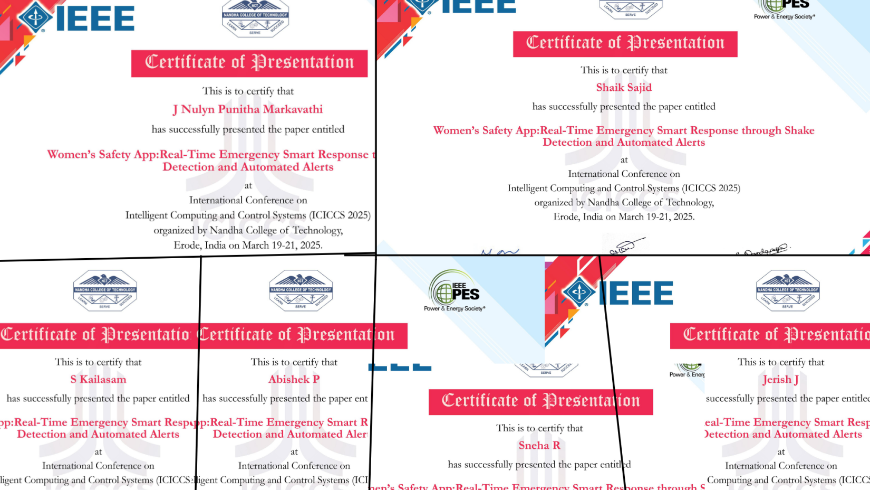

Fig 9: Certificates of Presentation

**Graphical Representation:**

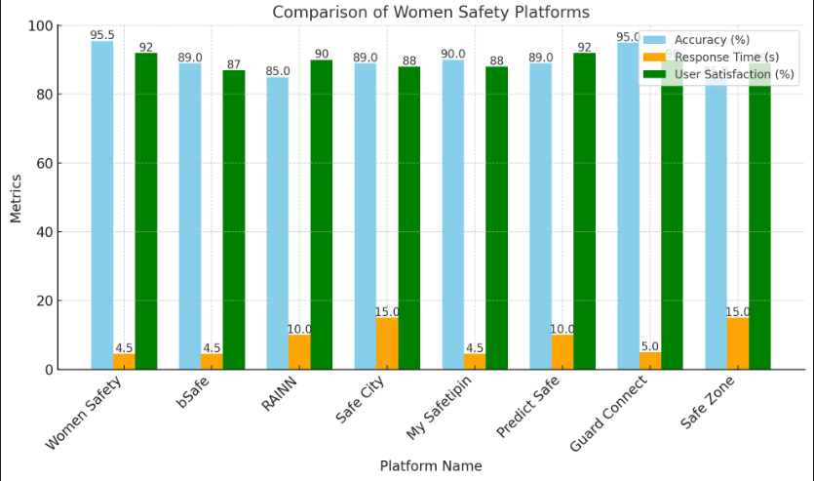

Fig 10: Graphical Representation of three key performance metric

In Figure 10 presents a comparative **bar graph** illustrating three key performance metrics—**Accuracy**, **Response Time**, and **User Satisfaction**—across various women’s safety platforms. Our proposed app demonstrates superior **accuracy** in detecting emergency situations via shake gestures, outperforming existing solutions. In terms of **response time**, the app shows a significantly quicker alert dispatch, thanks to its optimized background processing. Additionally, user feedback indicates a higher level of **satisfaction**, attributed to the app’s simplicity, effectiveness, and real-time responsiveness. This graphical comparison reinforces the reliability and efficiency of our application in real-world scenarios, validating its practical impact and user-centered design.

**5. CONCLUSION AND FUTURE WORK**

In conclusion, the development of the Women’s Safety App: Real-Time Emergency Smart Response through Shake Detection and Automated Alerts successfully addresses a critical gap in existing personal safety solutions. By integrating shake-based activation, real-time GPS tracking, emergency SMS and call features, and an audible siren, the app ensures a fast and effective response during distress situations. Its user-friendly interface and minimal activation steps make it particularly useful in high-stress scenarios, empowering users with a sense of control and immediate access to help. The feedback from community members and testing participants highlights the app’s potential to enhance safety for women, particularly in environments where immediate intervention is not always available.

Looking ahead, future iterations of the app will focus on enhancing its intelligence and adaptability. Planned upgrades include the integration of **AI-based threat detection**, **voice-command activation**, and **offline functionality** for low-network areas. Further, incorporating a **cloud-based alert history** for law enforcement and the inclusion of **multi-language support** will broaden the app’s accessibility and impact. We also aim to establish collaborations with local authorities and campus security teams to streamline emergency responses. Ultimately, the project lays a strong foundation for scalable, smart safety solutions that can be extended to various vulnerable communities beyond women alone.